Multi stage Algorithm

Noise Reduction

Find intensity gradient of the image(filter with sobel kernel in both horizontal and vertical direction

Non-maxium suppression (rescan image to remove, non local maxim pixels from edge, edge is thinned)

Hysteresis Thresholding(Discard edges outside of threshold and not connected to sure edges)

Code using cv.canny

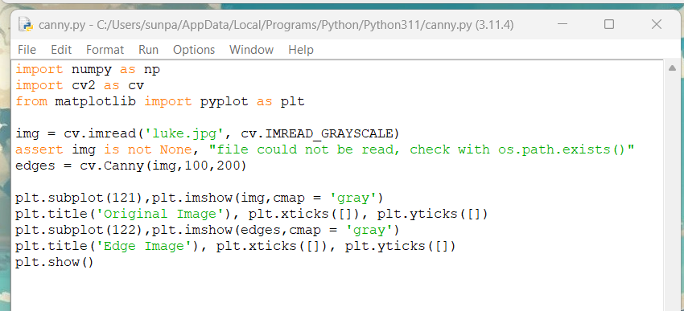

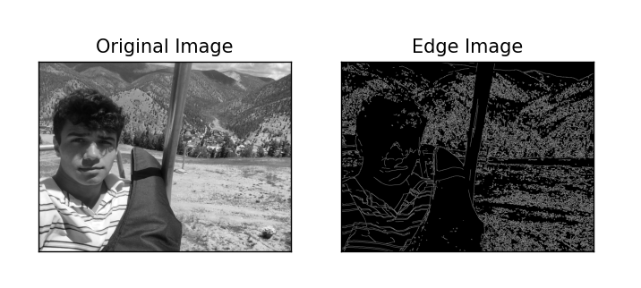

Results on luke.jpg, less detailed little objects in the distance get mixed up, objects in foreground with more detail are edged more accurately